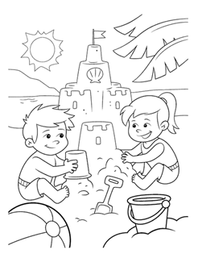
Breakfast
Served daily from 8am till 2pm
Bacon & Egg $8.50
One free range egg/bacon/toast
Pancakes $8.50
Two pancakes/ maple syrup/ one scoop vanilla ice cream/ candy floss
Kids Scramble $8.00
Two scrambled eggs/ toast

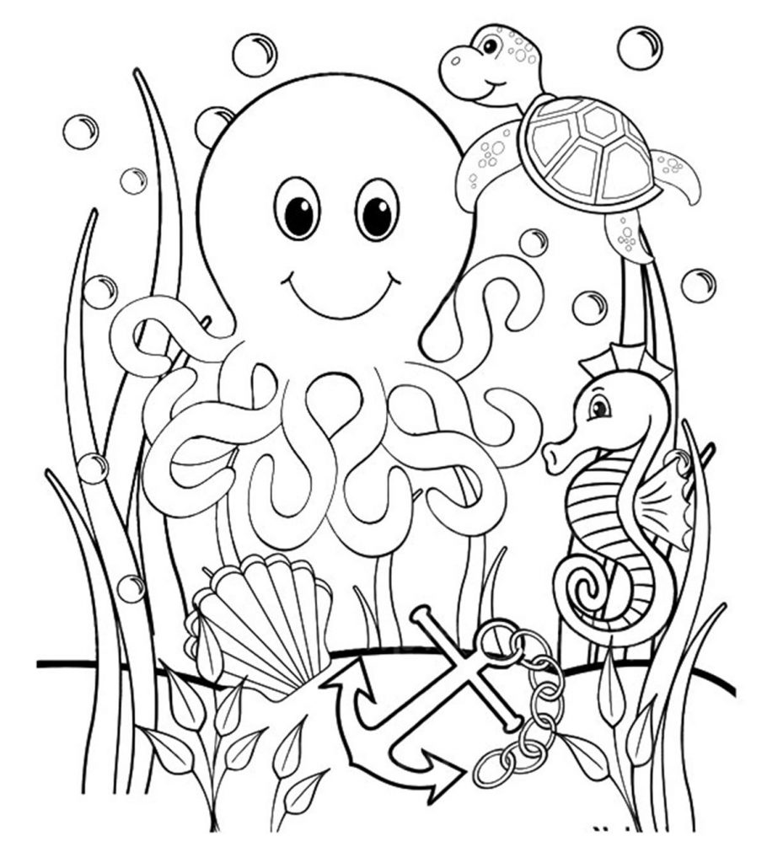
Main Meals
Served daily from 11:00 till late

Kids Fish $12.50
Battered fish/ Tomato sauce with either fries or salad

Kids Hotdogs $12.50
Mini Battered Hotdogs/ Tomato Sauce with either fries or salad

Kids Cheesy Pasta $14.50
Bacon/ Cheese/ Pasta/ Creamy Sauce

Kids Beef Burger $14.50
100g Beef burger/ Cheese/ Tomato Sauce/ Fries

Dessert

Kids Sundae $7.00
Vanilla Ice cream with wafer and either chocolate/ caramel or berry sauce

Kids Banana Split $9.00
Vanilla ice cream/ banana/ wafer with either chocolate/ caramel or berry sauce

Drinks
Small Juice $2.50
Apple/ Orange/ Cranberry/ Pineapple
Large Juice $5.00
Apple/ Orange/ Cranberry/ Pineapple
Smoothies $8.50
Tropical/ Mango/ Apple & Feijoa/ Banana/ Berry
Frappes $8.50
Chocolate/ White Chocolate

